**PROJECT DESIGNING PHASE-II**

**DATA FLOW DIAGRAMS**

|  |  |
| --- | --- |
| **Date:** | 10 October 2022 |
| **Team ID** | PNT2022TMID47824 |
| **Project Title** | Global sales data analytics |
| **Maximum Marks** | 4 marks |

**Data Flow Diagrams:**

A data-flow diagram is a way of representing a flow of data through a process or a system. The DFD also provides information about the outputs and inputs of each entity and the process itself. A data-flow diagram has no control flow — there are no decision rules and no loops.

**Example: Structural Flow Diagram:**

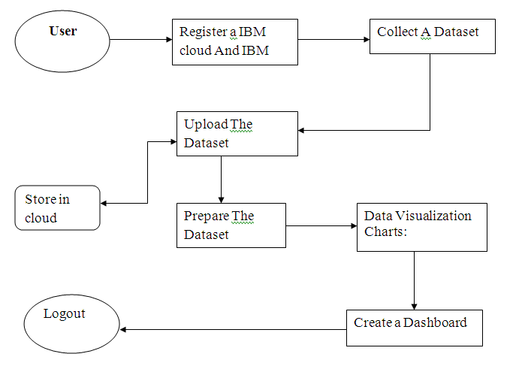

**DATA FLOW DIAGRAM FOR GLOBAL SALES DATA ANALYTICS:**

** 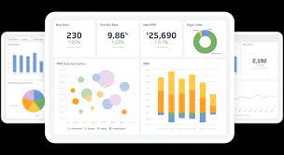  
USER Dashboard**

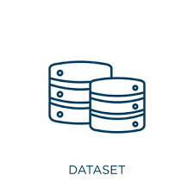 

**Dataset Prepare Data**

* **User login a IBM cloud and IBM cognos.**
* **Collect a sales dataset.**
* **Upload the data set IBM cognos.**
* **Prepare dataset.**
* **Visualized data set graphically (graph, chart).**
* **Crate a template.**
* **Create a Dashboard.**